PathWay AutoPrint/BatchPrint Installation and Set Up

- If client is currently using 4Medica, you must unistall the 4Medica Autoprint program.
- Go to GIConnect Website and download AutoPrint client program.
- Save the file to the desktop.
- Double click setup.exe.

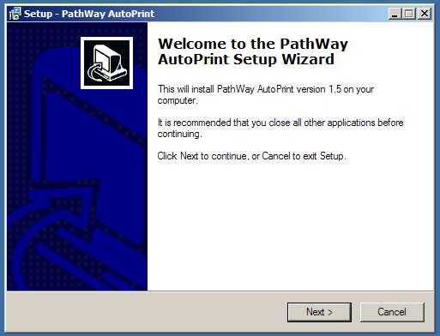

- Click [Next >]
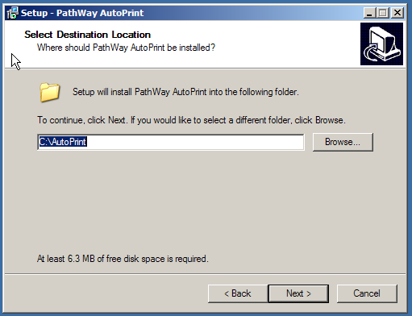

- Click [Next >]

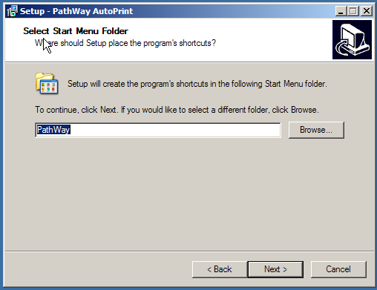

- Click [Next >]

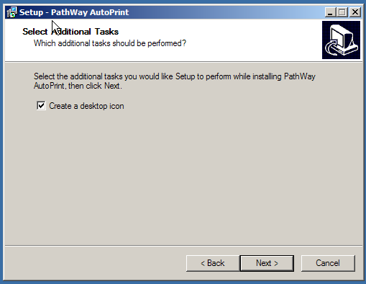

- Click [Next >]

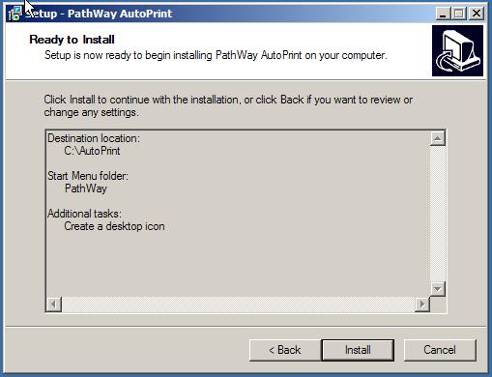

- Click [Install]

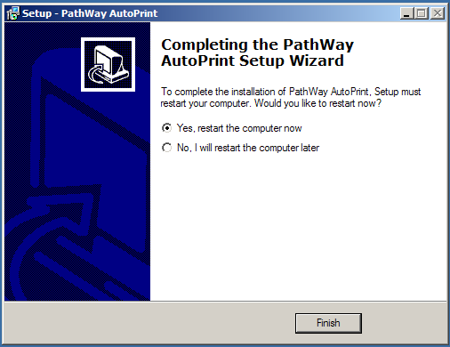

- Click [Finish]

After the computer has restarted the AutoPrint program will be minimized on the taskbar.

There are 2 methods for printing reports. Auto Print and Batch Print. Auto Print prints available reports after a given period of time, every 5 minutes or more. Batch Print prints at a certain time each day or when a [Print PDF’s Now] button is clicked.

AutoPrint Setup

1. Click PathWay AutoPrint Button on the Task Bar. The Print Monitor program will appear.

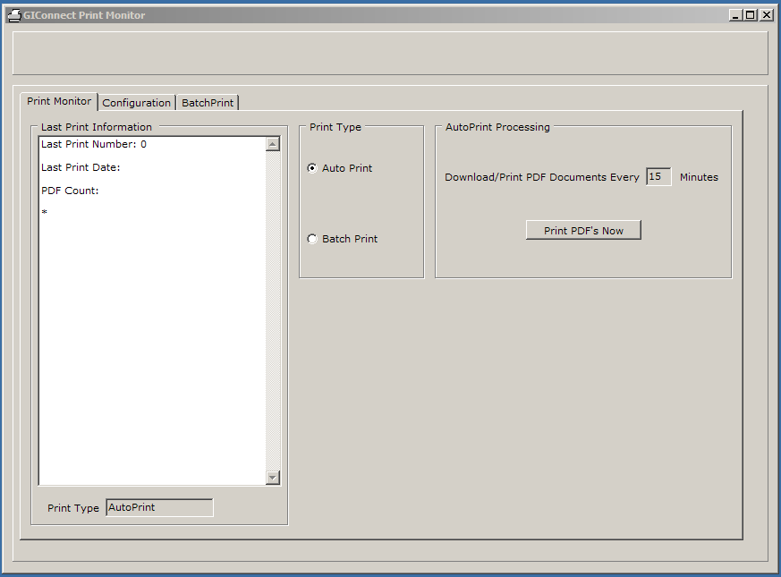

- Click Configuration tab.

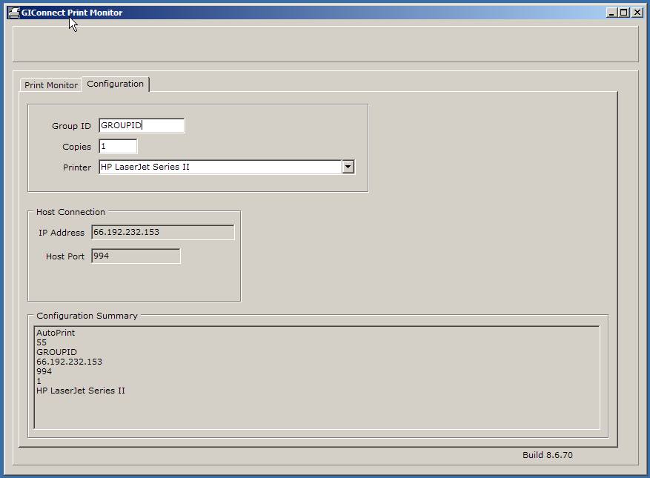

- The GroupID field is normally Read-Only. Double-Click ‘Group ID’ label. It will allow you to change the Group ID.
- Type the clients GroupID and press [Tab]. After you [Tab] out of the GroupID field, it will be Read-Only again.
- Type the number of copies to print if different than 1 and press [Tab].
- If the client is not using the default printer, you must click the down arrow and select the printer you want to use.
- Click Print Monitor tab.

- Click [Print Reports Now]

The program will login to the secure FTP site and download the test or actual reports. They will print to the default printer or the selected printer.

- Minimize program. It will autostart and run minimized if the computer is restarted.

Batch Print Setup

Click on the Batch Print radio button. A new group box appears with the information needed to set up the Batch Print process.

Batch printing can be done at a certain time each day or immediately when the [Print Reports Now] button is clicked.

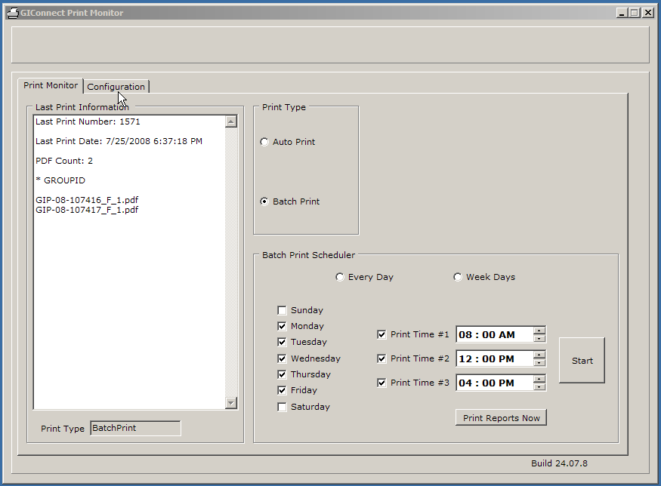

- The first step is to select the days of the week you wish to batch print reports. If you want to print on certain days of the week, click the appropriate days. If you want to print every day, click the [Every Day] radio button. It will automatically check all days. If you only want to print on weekdays, click the [Week Days] radio button and only the weekdays will be checked. You can check or uncheck specific days as well.
- You can batch print at up to 3 different times during the selected days. Change the Print Time to reflect the time you wish the batch printing to start. You must click the Print Time boxes to show the time applys. If you want to only batch print one time a day, just fill in the time and click the “Print Time #1” checkbox. If you want to print more than one time a day, fill out and click the appropriate Print Time fields.
- After filling out the Print Times you must click the [Start] button. It will print all the completed report at the specified days and times.
- If you wish to change the Print Times after starting the program, you must click the [Stop] button first. The Print Times are not changeable while the Batch Print program is active.
- Click the [Print Peports Now] button to test the connection.

